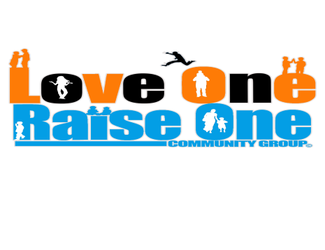
Volunteer Application Form

Contact Information
Name: _____________________________________ Date of Birth: ____/____/____ Phone: __________________
Address: ____________________________________________ City, State, and Zip: _______________________
Volunteer Position Information
What position are you applying for? (Board, Team, or Volunteer)__________________________________
What skills can you contribute to the organization? _________________________________________________
What experience do you have in this area? ________________________________________________________
What days will you be available? (List ALL that apply.) ______________________________________________
What times during these days will you be available? ________________________________________________
Education/Work Experience
Highest Level of Education: _________________________ Current Employer: ___________________________
Personal Reference: 1) _______________________________ 2) _______________________________________
(Please list name and contact information.)
Professional Reference: 1) ______________________________ 2) _____________________________________
Emergency Contact Information
Emergency Contact: ___________________________________________________________________________
Relationship to Contact: ______________________________ Phone: __________________________________
All applicants must answer the following questions. Failure to answer honestly WILL disqualify the applicant from service in ANY position with our organization.
Have you ever been convicted of a felony? YES ______ NO ______
If yes, please describe the conviction in GREAT DETAIL in the space provided:
_____________________________________________________________________________________________
_____________________________________________________________________________________________
By signing on the line provided, you agree that ALL information you have provided in this application are to be true to the best of your knowledge.

Signature: ________________________________________________________ Date: ______________________

Love One Raise One Community Group © All Rights Reserved

