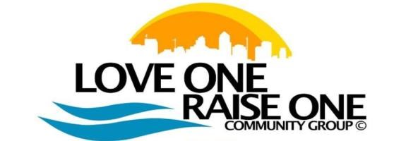
Mentee Application Form
(for youth under 18)

THANK YOU FOR YOUR INTEREST IN THE LOVE ONE RAISE ONE MENTORSHIP PROGRAM! THIS SECTION SHOULD BE COMPLETED BY THE YOUTH AND PARENT/GUARDIAN.

Youth First name: _____________________Last name: ______ Date of Birth: _________________
Address: ____________________________ If you do not have a home, where do you stay? ________________
Home phone: _( )____-____ Cell phone: _( )____-____ Email Address:______________________________
Name of school: _______________________ Grade: _________________________________________________
I Promise to respect the time of the LORO volunteer mentors and will devote my best efforts to fulfill the requirements of the program.
I Promise
What is the best way to contact you? (Please check one) Text ¤ Phone call ¤ Email ¤ Other (Please specify) ¤ Other members in the mentee/youth’s household:
Name | Gender | Age | Relationship to Youth

For The Parent:

Name: ___________________________ Other Names Previously Used: ______________________
Home Phone: ___________________ Cell Phone: _______________________ Email Address: ______________
Current Address: ___________________ How Long at this address? ___________________________________
What is the best way to contact you? (Please Check One) Text ¤ Phone Call ¤ Email ¤ Other(Please Specify) ¤
Relationship to Youth/Mentee: ________________ Do you live with the youth/mentee?(Check One) Yes ¤ No ¤
Does your youth have any special needs we need to know about? (If so, give details)____________________
Will you need help transporting your youth to meetings with the mentor? (check one) Yes ¤ No ¤
On a scale of 1 to 5 (1 being the least and 5 being the most) How involved will you be with this program?
(Circle One) Uninvolved 1 2 3 4 5 Very Involved
Emergency Contact:Name _________________ Relationship to Youth: ____________ Phone: ______________

We take pictures at most of our events. Do we have permission to post on our business page, web page or business cards? Yes______ No_________
A one time fee of $25 is due for mentee application. The application fee covers administration, maintenance, t-shirt, and development of the mentor program

Love One Raise One© All Rights Reserved

